Guvi Task:- MYSQL

1. **Code:-**

create database guviTask12;

use guviTask12;

create table Empl(empno int, ename varchar(30), job varchar(30), mgr int, hiredate date, sal decimal(10,2), comm decimal(10,2), deptno int);

desc Empl;

insert into Empl values (8369, 'SMITH' , 'CLERK', 8902, '1990-12-18', 800.00, NULL, 20);

insert into Empl values (8499, 'ANYA' , 'SALESMAN', 8698, '1991-02-20', 1600.00, 300.00, 30);

insert into Empl values (8521, 'SETH' , 'SALESMAN', 8698, '1991-02-22', 1250.00, 500.00, 30);

insert into Empl values (8566, 'MAHADEVAN' , 'MANAGER', 8839, '1991-04-02', 2985.00, NULL, 20);

insert into Empl values (8654, 'MOMIN' , 'SALESMAN', 8698, '1991-09-28', 1250.00, 1400.00, 30);

insert into Empl values (8698, 'BINA' , 'MANAGER', 8839, '1991-05-01', 2850.00,NULL, 30);

insert into Empl values (8882, 'SHIVANSH' , 'MANAGER', 8839, '1991-06-09', 2450.00, NULL, 10);

insert into Empl values (8888, 'SCOTT' , 'ANALYST', 8566, '1992-12-09', 3000.00, NULL, 20);

insert into Empl values (8839, 'AMIR' , 'PRESIDENT', NULL, '1991-11-18', 5000.00, NULL, 10);

insert into Empl values (8844, 'KULDEEP' , 'SALESMAN', 8698, '1991-09-08', 1500.00, 0.00, 30);

select * from Empl;

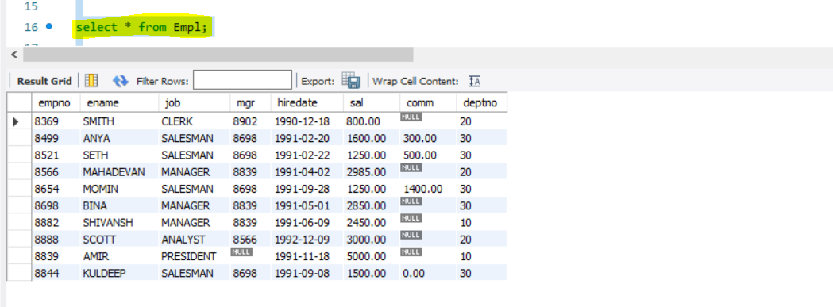

**OUTPUT:-**

1. **select ename,sal from empl where sal>=2200;**

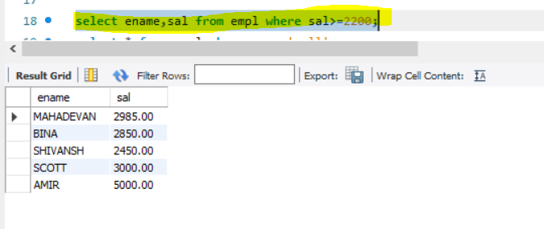

1. select * from empl where comm is NULL

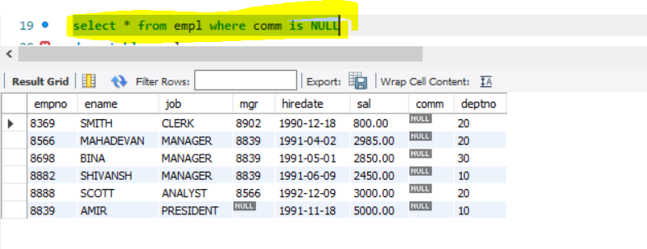

1. **select ename,sal from empl where sal not BETWEEN 2500 AND 4000;**

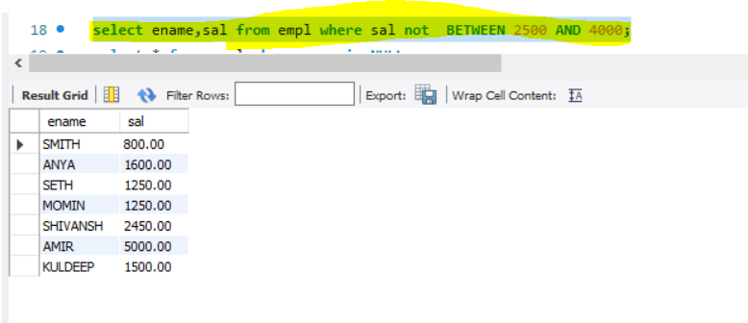

1. **select ename,job,sal from empl where job !='Manager';**

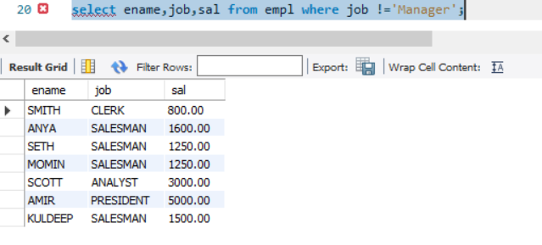

1. **select ename from empl where SUBSTRING(ename, 3, 1) = 'A';**

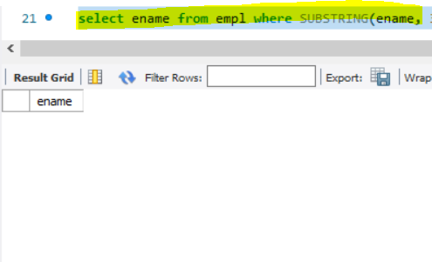

1. **select ename from empl WHERE ename LIKE '%T';**

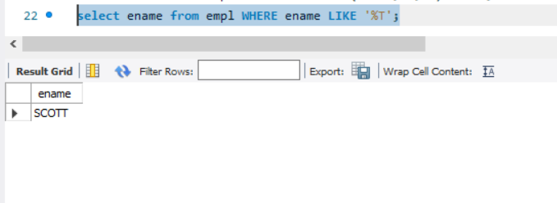

1. **Code:- Load data into SQL**

